ModenaCam 4

Flash/FMS->PHP Integration Documentation

- Integration diagram

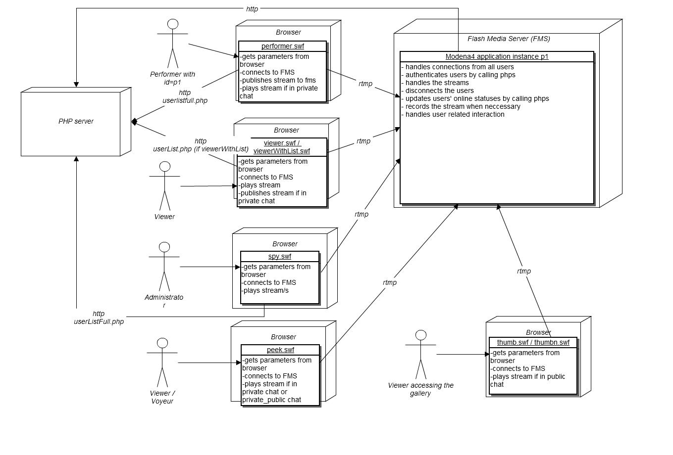
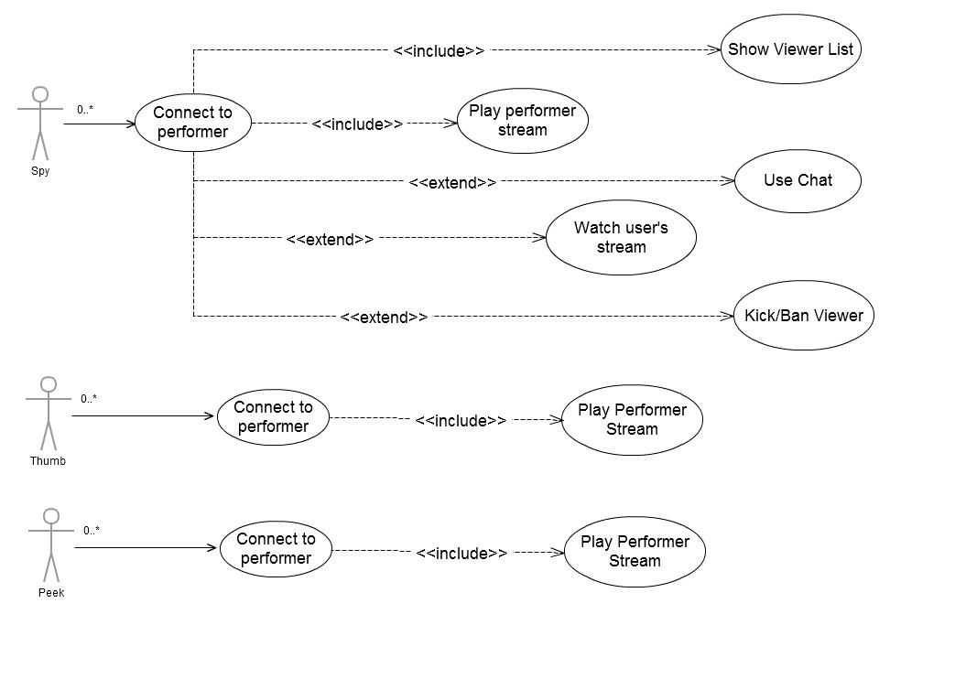
- Use Cases
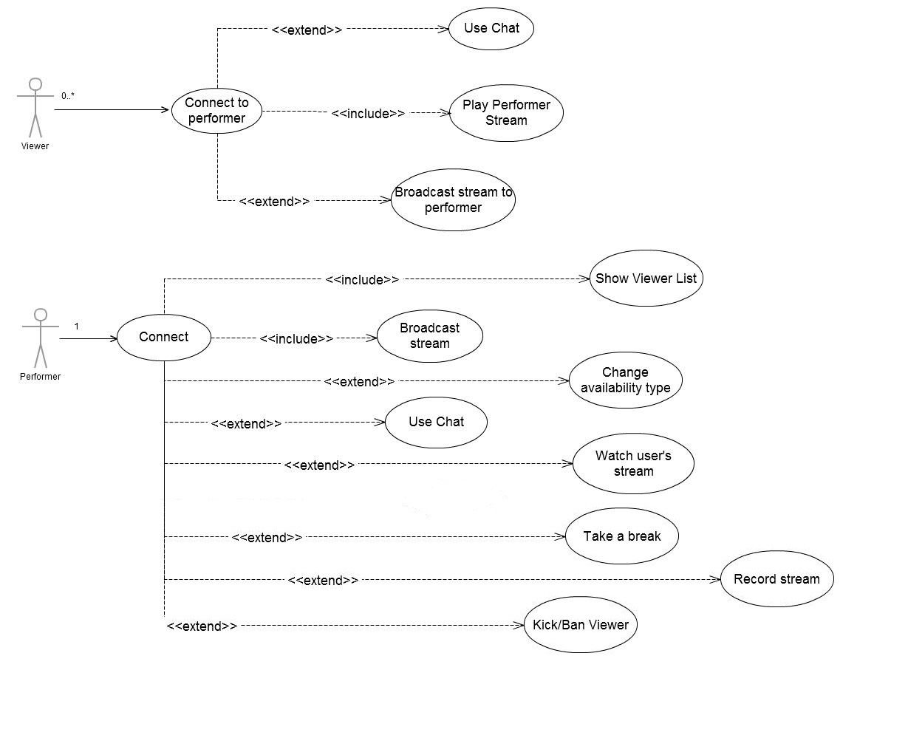

- Quick swf files' descriptions

performer.swf
        - used to broadcast the performer's stream to the FMS server
        - provides settings, chat and show features for the performer

viewer.swf
      - used to play the performer's stream from the FMS
      - provides an interface for the user to see the performer, chat with him/her , send an invitation to private chat, show the performer his own stream, listen to the performer's music, etc

viewerWithList.swf
      - same as viewer.swf, but has a list of all the users in the chatroom

spy.swf
      - an interface for the administrator of the site to supervise the performer
      - provides a set of features for the administrator to control his staff, like kick/ban user, see the performer's show regardless of session type, etc

peek.swf
      - used by a viewer to see a private show for a smaller fee than it would be to enter a private chat
      - does not offer chat option, just a video stream

delete.swf
      - when successfully connected to the FMS, it physically deletes the flv from the server

preview.swf
- used to offer a small window to preview a recorded video

thumb.swf
- a small thumbnail that shows the current stream of a performer
      - if the performer enters a paid chat, the thumb is disconnected automatically by the FMS

thumbn.swf
- same as thumb.swf, but shows a picture of the model and plays the stream just if you mouse over the swf clip

flvPlayer.swf
- plays a recorded video file

- SWF-HTML integration

performer.swf / performerFMLE.swf
size: 940x560 px

flash parameters:
bandwidthTestRtmp=rtmp://fms4.modenacam.com/VOD
        - used to detect available bandwidth

rtmp=rtmp://fms4.modenacam.com/@Modena4dev/
        - main application server side address

performerId=p1
        - the id of the performer (must be unique among users, no spy nor viewer can have this same id)

pasword=0
        - performer's password

userName=Gagica69
        - performer's nickname (as it will appear on site and chat)

uniqId=
        - a unique id for the session

nickColor=0x129400
        - the color of the nickname in the chat (hexa RGB)

sitePath=http://mysite.com/
        - path where theme.xml, translation.php, censure.xml, mp3.xml , userList.php, userListFull.php can be found (please note that emoticonsData.xml has to be accessible from the swf's directory level!!! )

recPrivateShow=true / false
        - true to record private sessions and private_public sessions

external files loaded (or called):

      - theme.xml (see example file)
      - censure.xml (see example file)
      - translation.php (see file)
      - emoticonsData.xml (see file)
      - mp3.php (see example file)
      - changeNude.php?random=[]&performerId=[]&pasword=[]&chatType= [1|2|3...|n]&label= → chatType is the index of the type found in translation.php under chatTypeOption[n] ; label is the label of the chatType listed in translation.php
      - userListFull.php?performer=[]&random=[]&userId=[]&pasword=[]
- returns the users strucutred in xml (see example file)
      - userList.php?performer=[]&random=[]
- returns the users strucutred in xml (see example file – other than userListFull.php)

viewer.swf / viewerWithList.swf
size:
viewer.swf:
normal: 940x540 px
double: 940x750 px
viewerWithList.swf:
normal: 1080x540 px
double: 1080x750 px

flash parameters:
rtmp=rtmp://fms4.modenacam.com/@Modena4dev/
        - main application server side address

performerId=p1
        - the id of the performer

pasword=0
        - the user's password

userId=v3
        - the user's id (must be unique among all user types)

userName=Bubulin
        - the user's nickname

uniqId=
        - a unique id for the session

sessionType=public / private_public / private
        - type of chat the users attempts to join (if the sessionType is not compatible with the performer's current session, the FMS rejects the user automatically)

chips=300
- available chips (site currency)

minChipsForPrivate=100
        - minimum chat currency amount to invite performer to private chat (used to show or hide the “invite” button , further authentication is done in the FMS side)

performersFeePerMinutePrivate=23
        - performer's charge per minute (in site currency)

performersFeePerMinuteTruePrivate=123
        - performer's charge per minute (in site currency)

redirectLink=http://www.yahoo.com
        - a redirect link for some disconnection cases

nickColor=0x99FF00
        - chat nickname color for current user

sitePath=http://mysite.com/
        - path where theme.xml, translation.php, censure.xml and mp3.xml can be found (please note that emoticonsData.xml has to be accessible from the swf's directory level!!! )

performerNick=
        - performer's nickname

performerNickColor=0x129400
        - chat nickname color for the peformer

noChat=false / true
        - toggle if chat is active or not

tipFileLink=http://tipFile.php

- if this parameter is missing, the button to send tips will not appear in the user interface
- GET paremeters: random & userId & pasword & uniqId
- the file returns: allow=true&min=10&max=100&noChips=false&notLogged=false

peekLink= used entering peek mode if performer enters private
this parameter will be passed to js: enterChatChoice(“private”, peekLink)
nudeLink= used for enetring nude show if performer enters nude
this parameter will be passed to js: enterChatChoice(“nude”, nudeLink)

external files loaded (or called):

      - theme.xml (see example file)
      - censure.xml (see example file)
      - translation.php (see file)
      - emoticonsData.xml (see file)
      - mp3.php (see example file)
      - userList.php?performer=[]&random=[]
- returns the users strucutred in xml (see example file)
- only viewerWithList.swf loads this file

javaScript functions called
      - large1(); - when display changes to double size
      - small1(); - when display changes to normal size
      - endShow(); - when the “End Show /Exit” button is pressed

spy.swf
size:
940x560 px

flash parameters:
rtmp=rtmp://fms4.modenacam.com/@Modena4dev/
-main application server side address
performerId=p1
-the id of the performer
pasword=0
- spy's password
userId=s1
- spy's id (must be unique among all user types
userName=SpyMan
- spy's nickname (in case he writes smth in the chat)
uniqId=
- a unique session id
nickColor=0x129400
- chat nickname color for current user
redirectLink=http://www.yahoo.com
- a link to direct to in some disconnection cases

external files loaded (or called):

      - theme.xml (see example file)
      - censure.xml (see example file)
      - translation.php (see file)
      - emoticonsData.xml (see file)
      - userListFull.php?performer=[]&random=[]&userId=[]&pasword=[]
- returns the users strucutred in xml (see example file)

peek.swf
size: 530x480 px

flash parameters:
rtmp=rtmp://fms4.modenacam.com/@Modena4dev/
        - main application server side address

performerId=p1
        - the id of the performer

pasword=0
        - voyeur's password

userId=v3
        - voyeur's id (should be the same as for viewer.swf)

userName=
        - voyeur's nickname

uniqId=
        - a unique session id

redirectLink=http://mysite.com/index.hml
        - redirect link for some disconnection cases

sitePath=http://mysite.com/
        - path where theme.xml, translation.php, censure.xml and mp3.xml can be found

external files loaded (or called):

      - theme.xml (see example file)
      - censure.xml (see example file)
      - translation.php (see file)

thumb.swf
size: 120x90 px

flash parameters:
rtmp=rtmp://fms4.modenacam.com/@Modena4dev/
        - main application server side address

performerId=p1
        - the id of the performer

thumbn.swf
size: 120x90 px

flash parameters:
photo= http://www.aaa.com/a.jpg
        - link for the photo to display

rtmp= rtmp://fms4.modenacam.com/@Modena4dev/
        - main application server side address

performerId= 1
        - the id of the performer

redirectLink= http://google.com
        - “on click” redirect link

delete.swf
size: 1x1 px

flash parameters:
rtmp=rtmp://fms4.modenacam.com/@Modena4dev/
        - main application server side address

performerId=p1
        - the id of the performer

pasword=0
        - password of the user intenting to delete the flv (it is verified by the FMS)

userId=d1
        - userId of the user intenting to delete the flv (performer / admin(spy) )

flvName=sfgs
        - the name of the flv file (without extension “.flv” )

uniqId=sdfgfsdgfgd
        - unique session id

preview.swf
size: 220x165 px

flash parameters:
rtmp=rtmp://fms4.modenacam.com/preview/
        - preview (for recorded .flv files) application server side address

performerId=p1
        - the id of the performer

flvName=streamer-1273176624747
        - the name of the flv file (without extension “.flv” )

uniqId=
        - unique session id
videoId=
          - Id to identify the video in the previewOpenVideoInModal(videoId) java script function (called when preview.swf is clicked)

external files loaded (or called):

      - theme.xml (see example file)

flvPlayer.swf
size: 640x480 px

flash parameters:
rtmp=rtmp://fms4.modenacam.com/playApp/
        - player (for recorded .flv files) application server side address

performerId=p1
        - the id of the performer

pasword=
        - password of the user who accesses the video

uniqId=
        - unique session id

videoId=
          - Id to identify the video in fms/playflv

userId=
        - id of the user accessing the video

userName=
        - user name of the user accessing the video

- FMS server-side integration

Basic idea:
When a user connects to the application using the flash component, it connects to the FMS where the details are validated and he is accepted or denied access.
When a user disconnects, the FMS signals that to the PHP side to update the data base.
Also, the FMS periodically calls a PHP file for each user to update online time and charge the right amount for paid shows.

Called files:
(as they appear in server side script, the path to these files is set in the script)
AUTHFILE = "auth.php";
AUTHFILE_PERFORMER = "performer/fms/auth";
TAXFILE = "tax.php";
VALIDATECHIPSFILE = "validateChips";
LOGFILE = "log";
ENDSESSIONFILE="endsession";
BANFILE = "banmanager.php";
DELETEVIDEOFILE = "deletevideo";
ADDVIDEOFILE = "addVideo";
TIPFILE=”tipFile”
TRUEPRIVATE="fms/trueprivate"

  - AUTHFILE / AUTHFILE_PERFORMER
    - called by the FMS when a user / performer connects to the application
    - depending on the result of this file, the user's connection is accepted or denied

parameters to the file are sent via POST and are the following:
      - ip =
      - userId =
      - userType = viewer / performer / spy / fmle
      - pasword =
      - uniqId =
      - userName =
      - performerId =
      - sessionType = (for viewer only)
      - hash= (from the FMS side script – hardcoded and constant)
      - numberOfCameras = (for performer only) – number of active cameras the performer has going (between 1 and 3)
      - md5 = ( only for viewer ) MD5( chips+minChipsForPrivate+performersFeePerMinute+nickColor+noChat)

parameters returned:
      - status = allow / deny (specifies if the user can or cannot connect)
      - color = the viewer's nickname color (see viewer.swf parmeters -> nickColor) – only applies for viewers, it's purpose is to validate the chat line information as in previous versions, users changed their color/nickname. If this parameter is missing, the color is no longer verified in chat line posting, but the nickname however is always verified.

  - TAXFILE
    - called by the FMS once every 5 seconds (if the performer is online), for each viewer to properly charge him and update his online time
    - depending on the result of this file, the user's connection is kept or disconnected

parameters to the file are sent via POST and are the following:
      - userId =
      - userType = viewer
      - pasword =
      - uniqId =
      - performerId =
      - sessionType = public / public_private / private / peek
note: if a user is accepted in private chat, the AUTHFILE is not called again, but here in TAXFILE, the sessionType changes to private
      - hash = (from the FMS side script – hardcoded and constant)

parameters returned:
        - status = allow / deny (allow- continue viewing, deny- disconnect user)
        - disconnectionType = (optional parameter; if passed, the viewer's swf will search for that string in the translation file and show the message to the user as the reason of disconnection e.g.: disconnectionType=noMoreChips ->>> noMoreChips=”You need to buy more chips and re-enter chatroom!” in the translation.php . If that string is not in the xml, NO message is shown in the popup)

  - VALIDATECHIPSFILE
    - called by the FMS when a user invites a performer to private chat.
    - its purpose is to validate the user's information before sending an invitation to the performer as not to disturb if the user hasn't got enough chips, or his information is not valid

parameters to the file are sent via POST and are the following:
      - ip =
      - userId =
      - pasword =
      - uniqId =
      - userName =
      - performerId =
      - hash= (from the FMS side script – hardcoded and constant)

parameters returned:
        - status = allow / deny + allowChat; // allowChat= 0/1 0-no chat, 1- chat pentru viewer la auth

  - LOGFILE
    - called by the FMS when the performer disconnects from the FMS
    - its purpose is to add the chat logs in the data base

parameters to the file are sent via POST and are the following:
      - performerId =
      - pasword =
      - mess = the full log (complete with chat line postage time in full format)
      - hash = (from the FMS side script – hardcoded and constant)

parameters returned:
none

  - ENDSESSIONFILE
    - called by the FMS when a user disconnects
    - its purpose is to let the PHP side know when a user has disconnected and then update the data base accordingly

parameters to the file are sent via POST and are the following:
      - userId =
      - userType = viewer / performer (spy is not handled, it is not important to know when he disconnects)
      - pasword =
      - uniqId =
      - performerId =
      - ip =
      - hash= (from the FMS side script – hardcoded and constant)

parameters returned:
      - status = ok / error (or anything besides “ok” if there was an error updating the db) if the status is not “ok”, the script will try 4 more times to call the php before giving up

  - BANFILE
    - called by the FMS when the performer/spy bans a viewer
    - its purpose is to log the viewer (and IP) and not let him connect to the current performer for a designated time-span

parameters to the file are sent via POST and are the following:
    - ip =
    - bannedUserId =
    - performerId=
    - userId = (id of the user initiating the ban – spy or performer)
    - pasword= (password of the user initiating the ban – spy or performer)

parameters returned:
none

  - DELETEVIDEOFILE
    - called by the FMS when the delete.swf file connects to the FMS
    - its purpose is to authenticate the request to delete a video

parameters to the file are sent via POST and are the following:
      - performerId =
      - userType =
      - userId =
      - uniqId =
      - pasword =
      - flvName=
      - hash=

parameters returned :
      - status = allow / deny

  - ADDVIDEOFILE
    - called by the FMS when a video is successfully recorded

parameters to the file are sent via POST and are the following:
      - performerId =
      - hash = hash ;
      - userType =
      - userId =
      - uniqId =
      - pasword =
      - lengt = (length of the video in seconds)
      - flvName =

parameters returned :
none

  - PLAYFILE (from recorded video player app)
    - called by the FMS when a viewer accesses a recorded video

parameters to the file are sent via POST and are the following:
      - performerId = id of the performer who recorded the accessed video
      - ip=
      - hash = hash
      - userId =
      - uniqId =
      - pasword =
      - videoId =

parameters returned :
      - status = allow/deny
      - videoName = name of video file (without extension)

  - PLAYENDSESSIONFILE (from recorded video player app)
    - called by the FMS when a viewer leaves a recorded video

parameters to the file are sent via POST and are the following:
      - performerId = id of the performer who recorded the accessed video
      - ip=
      - hash = hash
      - userId =
      - uniqId =
      - pasword =
      - videoId =

parameters returned :
      - status = ok / error

  - TIPFILE
    - called by the FMS when a viewer tips the model

parameters to the file are sent via POST and are the following:
      - performerId = id of the performer who should receive the tip
      - hash = hash
      - userId = id of the user sending
      - pasword =
      - uniqId =
      - amount = amount for the tip

parameters returned :
      - status = ok / error

  - TRUEPRIVATE
    - called by the FMS when a viewer enters private chat to mark if peeking is allowed or not

parameters to the file are sent via POST and are the following:
      - performerId = id of the performer
      - hash = hash
      - userId = id of the user entyering private
      - isTruePrivate = true / false

Connecting using the FMLE component

FMLE settings:
rtmp: rtmp://<fms server>/<app name>/<performerId>?userId=<>&uniqId=<>&pasword=<>&userName=<>&performerId=<>

stream: cam1

